Empathy map canvas

### Use this framework to empathize with a customer, user, or any person who is affected by a team’s work.

Document and discuss your observations and note your assumptions to gain more empathy for the people you serve.

Originally created by Dave Gray at

✴

# Develop shared understanding and empathy

Summarize the data you have gathered related to the people that are impacted by your work. It will help you generate ideas, prioritize features, or discuss decisions.

**Smoothing and Resampling of points**

Analyze every text format

**To reduce manual work**

**Simple upload and Model from upload**

they

What do

Hear?

What do they think and feel?

To Normalize strokes of irregular size and missing points

**Remove variations with slant corrections**

Makes Documents editable

Organization factors that operate on system

Automatic Conversion is required

Store the image& see its link in homepage itself

**wHAT DO THEY SAY AND DO?**

Superior data security

## Delay to Decode

Data Loss

much more computation than other techniques like OCR

PAIN

Wide range of handwritten good & bad with broken edges

Reviewed when required

No manual requirement

GAIN

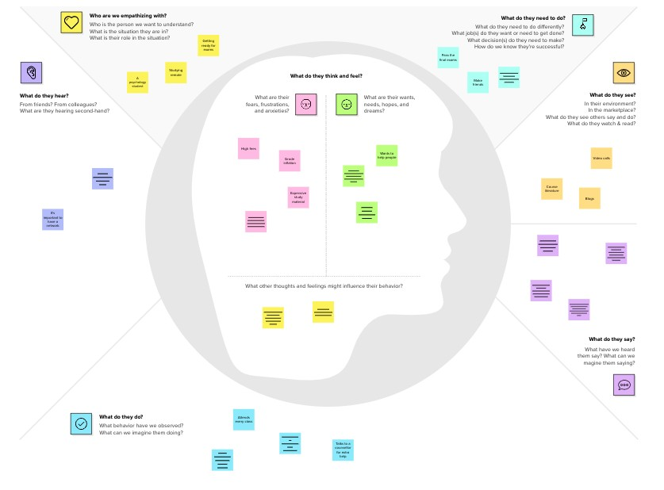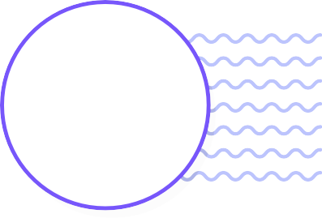

100% text searchable document

What do they see??

Quality in output

A NOVEL METHOD FOR HANDWRITTEN DIGIT RECOGNITON SYSTEM

**Template**

[**Share template feedback**](https://muralco.typeform.com/to/CiqaHVat?typeform-source=app.mural.co)

Historical facts can be stored

Shaping Organisatio n

It is apporipriate for immediate text input

Fear of sending written Datas

**Need some inspiration?**

See a finished version of this template to kickstart your work.

[**Open example**](https://app.mural.co/template/018339d6-ff71-42d8-9e5c-abddde77d5ab/982236e0-c7e5-4fb6-83e9-ef1b972b25bd)